H.T No
Regulations:
A18

Sreenidhi Institute of Science and Technology
(An Autonomous Institution)
Code No: 7B726 Date: 30-Dec-2022 (AN)

B.Tech IV-Year I- Semester (A18) Special Supplementary Examination - December-2022
OPERATION RESEARCH - (PE-I) (ME)

Time: 3 Hours Max.Marks:70

Note: a) No additional answer sheets will be provided.
b) All sub-parts of a question must be answered at one place only, otherwise it will not be valued.
c) Missing data can be assumed suitably.

ANSWER ANY 5 OUT OF 8 QUESTIONS. EACH QUESTION CARRIES 14 MARKS.

Bloom's Cognitive Levels of Learning (BCLL)
Remember | L1 | Apply | L3 | Evaluate | L5
Understand | L2 | Analyze | L4 | Create | L6

 |  |  | BCLL | CO(s) | Marks
1. | a) | A company manufactures two products X and Y. The profit contribution of X and Y are Rs.3/- and Rs. 4/- respectively. The products X and Y require the services of four facilities. The capacities of the four facilities A, B, C, and D are limited and the available capacities in hours are 200 Hrs, 150 Hrs, and 100 Hrs. and 80 hours respectively. Product X requires 5, 3, 5 and 8 hours of facilities A, B, C and D respectively. Similarly the requirement of product Y is 4, 5, 5, and 4 hours respectively on A, B, C and D.  - Formulate and Evaluate the given LPP  - Find the optimal product mix to maximise the profit by using graphical method | L5 | CO1 | [7M]
 | b) | 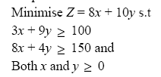 | L4 | CO1 | [7M]
2. |  | Find the Optimal Solution for least cost transportation cost.(North-West corner method)  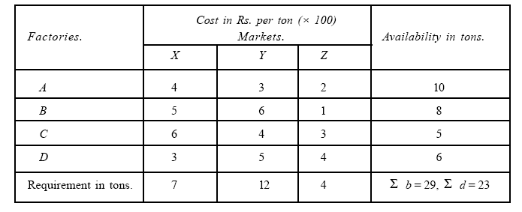 | L3 | CO2 | [14M]
3. |  | A company has 6 jobs which go through 3 machines X, Y and Z in the order XYZ. The processing time in minutes for each job on each machine is as follows: Determine the Optimal sequence, total elapsed time and idle times for each machine. | L3 | CO3 | [14M]
   |  | Job
   |  | 1 | 2 | 3 | 4 | 5 | 6
  Machines | X | 18 | 12 | 29 | 36 | 43 | 37
  Machines | Y | 7 | 12 | 11 | 2 | 6 | 12
  Machines | Z | 19 | 12 | 23 | 47 | 28 | 36
4. | a) | Discuss about the application of LPP in game theory with an example | L2 | CO4 | [7M]
 | b) | Find the solution of the game whose payoff matrix is given below:  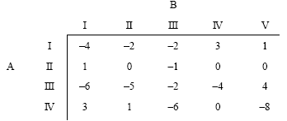 | L3 | CO4 | [7M]
5. | a) | Explain the applications of queue models in a business situation. | L3 | CO5 | [7M]
 | b) | In a bank, cheques are cashed at a single ‘Teller’ counter. Customers arrive, at the counter in a Poisson manner at an average rate of 30 customer per hour. The teller takes, on an average a minute and a half to cash cheque. The service time has been shown to be exponentially distributed.  (i) Calculate the % of time the teller is busy and  (ii) Also calculate the average time a customer is expected to wait. | L5 | CO5 | [7M]
6. |  | The average inter arrival of time at a telephone booth is 1.4 min. The average duration of a call is found to be 3 min. Simulate the situation to analyze the performance of booth for 10 min in terms of average waiting time of customers, average waiting time of customer who must have to wait, idle time of booth and booth efficiency. (Assume the system is empty initially and first customer arrives at time t = 0). | L4 | CO6 | [14M]
7. | a) | Discuss the types and characteristics of models used in operations research. | L2 | CO1 | [5M]
 | b) | What is meant by unbalanced assignment problem? Explain briefly. | L1 | CO2 | [5M]
 | c) | Describe various sequencing models. | L2 | CO3 | [4M]
8. | a) | What is meant by Rectangular Game? Differentiate between Pure Strategy and Mixed Strategy in a game? | L1 | CO4 | [5M]
 | b) | A company uses 24000 units of a raw material which costs Rs. 12.50 per unit. Placing each order costs Rs. 22.50 and carrying cost is 5.4% per year of the average inventory. Find the economic order quantity. | L3 | CO5 | [5M]
 | c) | What is Simulation? Discuss one application area where it can be used? | L1 | CO6 | [4M]

-- 00 -- 00 –

